A COMPARATIVE ANALYSIS OF THE KRITI FORM AS HANDLED BY SHYAMA SHASTRI, TYAGARAJA AND MUDDUSWAMI DIKSHITAR

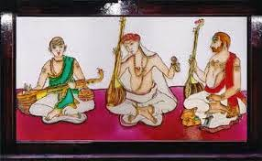

It is well known that the kriti is the most important musical form in South Indian music. The Musical trinity Shyama Shastri (1762-1827), Tyagaraja (1767-1847), and Muddusvami Dikshitar (1776-1835) were great composers of the kriti form and raised it to an unprecedented levels of musical excellence. Trinity’s kriti’s have immense richness of music and high flexibility. Here, the anga’s Pallavi, Anupallavi and Charana were not mere sections, but important stages of musical expressions and development. Kriti’s of the trinity offer maximum scope for musical freedom on account of their dynamism. It is only in the kriti form that these great composers have evolved their distinctive compositional styles.

Kriti’s of Tyagaraja have an endless variety in music and rhythm like the Kshetragna’s padam’s. The music of the Anupallavi is usually repeated in the Charana in Tyagaraja’s kriti’s. It is also said that he was the first one to have introduced sangati’s or melodic variations to unfold the raga stages. In the kriti’s of Shyama Shastri there is a two dimensional treatment of music and rhythm. His specialty was svara - saithya with its natural, yet highly aesthetic musical flow. Mudduswami Dikshitar is known for his grand style in the treatment of raga. In Dikshitar’s kriti’s there is no such musical repetition as in Tyagaraja’s kriti’s. Yet another feature of Dikshitar is the madhyamakala sahithya which, very effectively portrays the entire raga structure in a nutshell. The longer Anupallavi in the place of Charana is also typical of Dikshitar’s compositional style. Such an Anupallavi is in the modern times referred to as Samashatri Charana.

THE KRITI STYLES OF THE TRINITY- A GENERAL STUDY

Tyagaraja’s style is simple, spontaneous and captivating. It requires caliber of a very high order to present a simple style. Scholars usually compare Tyagaraja’s style to Srimad Bhagavadgita. The Bhagavadgita is in very simple Samskrita and yet it contains the essence of Indian philosophy. Tyagaraja’s kriti’s appeal to the classes as well as the masses. They are compared to grapes (Draksha rasa), which taste sweet at once. They can be sung with ease and confidence. A majority of Tyagaraja kritis are in Telugu language.

Kriti’s like Evarimaata (Kamboji) Kshirasgara sayana (Devagandhari) Koluvaiyunnade (Bhairavi) are typical examples of Tyagaragaja’s style. Tyagaraja’s Ghanaraga pancharatna are a class by themselves. His other group kriti viz the Kovur Pancharatnam and the Tiruvorriyur panchartnam are also widely sung.

Muddusvami Dikshitar’s music style in his kriti’s is that of a Vainika. It is compared with the great epic poems on account of its solidarity of art. Dikshitar’s kriti’s are compared to the coconut (Narikela rasa) on account of the initial hardship involved in understanding and enjoying their intrinsic merit. In order to taste the coconut one has to remove the fiber and break the shell. The kriti’s Balagopala (Bhairavi ) Sri Rajagopala (Saveri) Dakshina Murthy (Shankarabharana) are classic examples of Dikshitar’s style. Dikshitar has sung in praise of many gods and goddesses, whose shrines he had visited. The Navagraha kriti’s shodasaganapati kriti’s, panchalingasthala kriti’s are some of the well known kriti’s of Dikshitar. His kriti’s are in chaste Samskrita.

Shyama Shastri’s kriti’s style is peculiar as it is neither simple as Tyagaraja’s nor laborious as Dikshitar’s. He has composed mostly in Telugu and occasionally in Samskrita and Tamil. In all kriti texts we find the attitude of a child to its mother. They are in the form of fervent appeal to goddess mother. From the point of view of rasa Shyama Shastri’s kriti’s are compared to the plantain fruit (Kadali rasa) where one has to only peel off the rind to eat the fruit. The kriti’s “O Jagadamaba” (Ananadabhairavi), “Ninne namminanu (Todi), Ninnu Vinaga mari (Puravakalyani) are examples of Shyama Shastri’s musical style. His three Svarajati’s in the raga’s Todi, Bhairavi and Yadukula Kambhoji and his Navartna malika kriti’s are outstanding compositions.

A COMPARATIVE ANALYSIS OF THE KRITI FORMS OF THE TRINITY WITH RESPECT TO MELODIC RHYTHMIC AND OTHER TECHNICAL ASPECTS

The available compositions of Tyagaraja with music number a little less than seven hundred. In Tyagaraja’s kriti’s the following categories are seen.

a. Simple kriti’s like Sri Jananki manodhara(Isamanohari), Tolinenujeyu (Kokiladhvani) , Sitpate (Khamas) Nee Bhakti Bhagya Sudha (Jayamaonhari).

b. Kriti’s which are in the medium category. Tulasi bilva (Kedaragaula), Etavunan ercitivo (Yadukulakambhoji), Gitarthamu (Suruti raga), Lekana (Asaveri).

c. Advanced types of kriti’s with many sangati’s of different complexities. Cakkani Raja (Kharaharapriya), Epapamu (Athana), Najivadhara (Bilahari), Darini telusu(Suddha saveri). About two hundred and fifty compositions of Dikshitar are available; it is interesting that only about twenty five to thirty Dikshitar kriti’s were known to musicians in the older days. It was only after the publication of the Sangeetha Sampradaya Pradarsini many other kriti’s were brought to limelight.

In Dikshitar’s kriti’s classification into simple, medium and advanced types (as in Tyagaraja kriti’s) is not possible because whether long or short all Dikshitar kriti’s have more or less the same melodic complexity. Recently a number of very simple kriti’s have been popularized. Some of them seem to the spurious.

In the kriti’s of Shama Shastri not only the musical flow but also the length of the composition has also been maintained more or less uniform. About seventy compositions of Shyama Shastri are available to us.

RAGA TREATMENT IN THE KRITI FORMS OF THE TRINITY

Tyagaraja has handled about two hundred Raga’s in his kriti’s he has composed in about forty melakarta raga’s in all the popular janya raga’s and in many rare raga’s. About seventy new raga’s have been handled by Tyagaraja for the first time.

E.g: Umabharanam, Nalinakanti,Malayamarutam, Siddesena, Jayanarayani and Abhogi. In many kriti’s in the rare raga’s the musical structure in the Pallavi in just a sketch explaining the raga.

Nijamaramulanu in the raga Umabharana one kalai Adi tala.

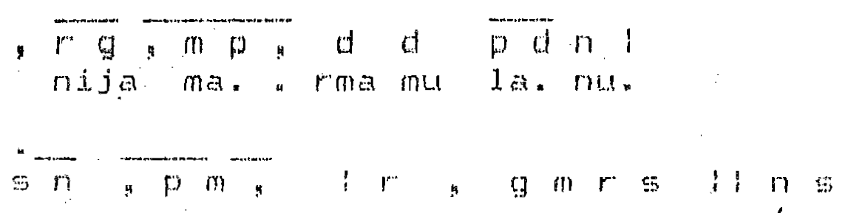

Thus it is clear that the Arohana and Avarohana of the raga Umabharanam is

Sa RI Ga Ma Pa Dha Ni SA,
Sa Ni Pa Ma RI Ga Ma RI SA.

Such simple picturisation of raga with scalar treatment is characteristic of Tyagaraja kriti’s.

The total number of raga’s found in Dikishtar’s kriti’s number about one hundred and sixty. Special care has been taken to work beautifully into the text of the songs, the names of the ragas. The line “Samsaarabhityapahe” in the kriti Sri Sarasvati Namostute in Arabhi raga is a classic example. The raga name Arabhi is very dexterously woven into the text of the song. Thus there are no doubts or disputes regarding the ragas of the kriti’s of Dikshitar. Rare raga’s like Mangalakaisiki, Kannadabangala, Ardraesi, Jayasuddhamalvai and Maahuri have been immortalized in the kriti’s of Dikishitar. Some of these ragas had existed even before the trinity’s period; Dikshitar has brought out the archaic form of these raga’s very effectively.

The raga treatment of Dikishtar in different from that of Tyagaraja. The musical structure consists of specific raga phrases which are very effectively put together to present a sound majestic musical statement.

Consider the kriti Tyagaraja yoga vaihavam in Anandabhairavi raga- tisra eka tala.

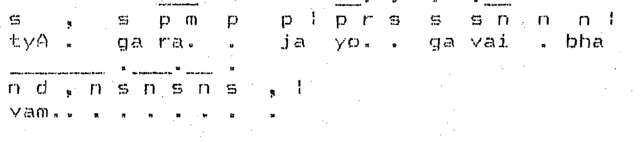

The above is just the first time of the Pallavi of the kriti, see how the phrases.

When joined together establish the raga Anandabhairavi with all its grandeur. Shyama Shastri has handled about thirty three ragas in his composition. The rare raga’s seen in his kriti’s are Karnataka kapi, Chintamani and Kalgada.Like Tyagaraja and Dikshitar, Shyama Shastri has not composed in the seventy two melakarta raga’s, raga’s handled by Shyama Shastri are Todi,Bhairavi,Kkambhoji, Sankarabbarana and Kalyani. His treatment of Anandabhairavi is unique he has composed five kriti’s in this raga.

Shyama Shastri has his own style of presenting the raga in the kriti. There is a certain whirling movement of the raga phrases in the musical structure of Shyama Shastri.

Durusuga krupajiuci saveri raga, Adi tala

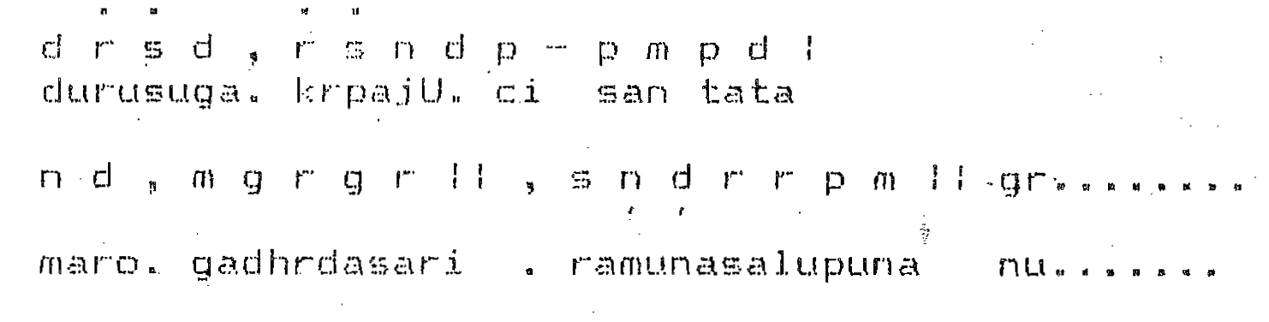

TALA’S IN THE KRITI’S OF THE TRINITY

Tyagaraja has handled all the important tala’s in his kriti’s. A bulk of the kriti’s are in Adi tala. All possible prastara’s of Adi tala are found in one or other of his kriti’s, while he was the first composer to have composed in Desadi and Madhyadi which were popular in Marathi devotional songs.

Samples of Desadi tala kriti’s of Tyagaraja
- Enta vedukandu - Sarasvati manohari
- Brova Barama - Bahudari

Samples of Madhyadi kriti’s of Tyagaraja
- Gitarthamu - Surati
- Nama Kusumamula - Sriraga

Quite a number of Tyagaraja kriti’s are set in Rupaka tala.
- Manasa etulortune - Malayamarutam.
- Sujanajivana- Khamas raga.

He has also composed kriti’s in Misra chapu tala, Nidhi chala sukhama in Kalyani stands out. There are also kriti’s in Tisra triputa tala with specific accents on the first, fourth and sixth counts.
- Enduku Daya radu – Thodi
- Guruleka – Gowrimanohari
- Toli Janma – Bilahari

Many kriti’s of Dikshitar are set in tisra eka vilamaba kala and misra eka tala’s. Navargarha kriti’s are in the suladi sapta tala’s. Dikshitar has composed in rare time measures like Khanda eka, Sri Dumdurge in Sriranjini is a good example.

Shyama Shastri kriti’s are set in Adi, Rupaka,Misra chapu and Triputa tala’s. Rare tala’s like Tisra mathya and Caturasra ata are also handled occasionally. The kriti structure in adi tala is in such a manner that it can be sung in both one kalai and two kalai. In the Rupaka tala, Shyama Shastri for the first time introduced the peculiar commencement of the kriti’s after one akshara kala e.g. Himadri sute in Kalyani. He also gave new dimensions to the Chapu tala. He not only reversed the tala as 4 + 3 but also treated the tala in yet another way as 2+3+2 in the same reversed pattern Ninuvinga in Purvakalyani 4+3 and Nannu brouvu in Lalita 2+3+2 are standing examples.

IDENTIFICATION OF COMPOSITIONAL STYLES OF THE TRINITY

After studying a number of different types of kriti’s of the trinity we are able to identify the authorship of any kriti of the trinity and also define the compositional style of each composer with reasonable certainty, even when we hear the songs played on the instruments.

In Tyagaraja kriti’s there are musical phrases of various patterns and sizes in madhyama kala being inherent in the musical structure itself. These madhyama kala phrases are interspersed with sama kala phrases.

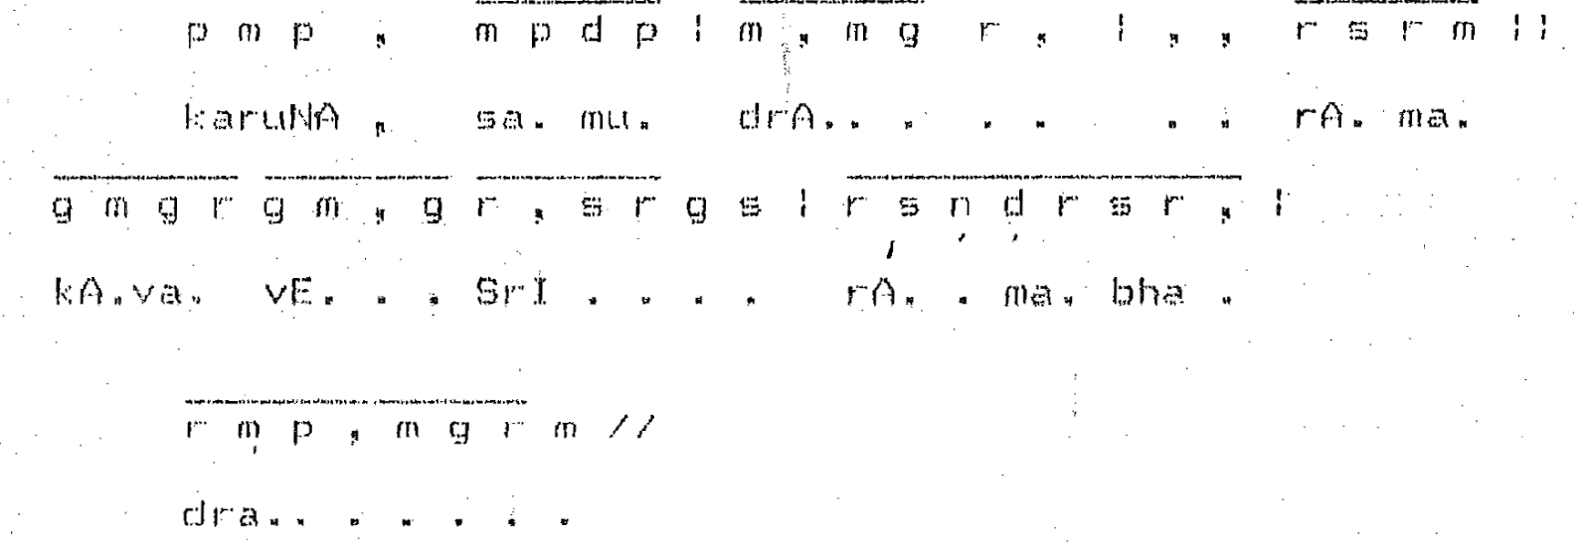

Along with the madhyama kala musical phrases trikala phrases are also sometimes found inherent in the basic musical structure of the kriti.

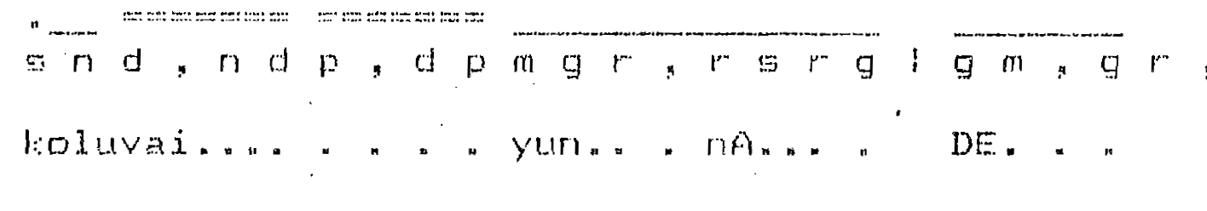

The above is the beginning of the kriti “Koluvaiyunnade” in the raga Devagandhari set to Adi tala.Another characteristic feature of Tyagaraja is the presentation of Sangati’s. Even in simple kriti’s there are at least a few sangati’s. In kriti’s like Chakkani margamu in kharaharapriya, we find a special technique of presenting the basic theme itself with a different musical structure thus affording scope for developing fresh Sangati’s from thereof.

Muddusvami Dikshitar’s compositional style is basically a vainika style. This style is characterized by a number of specific phrases with a certain flow of musical evenness.

Kamalambam Bhajare in the raga Kalyani - Adi tala

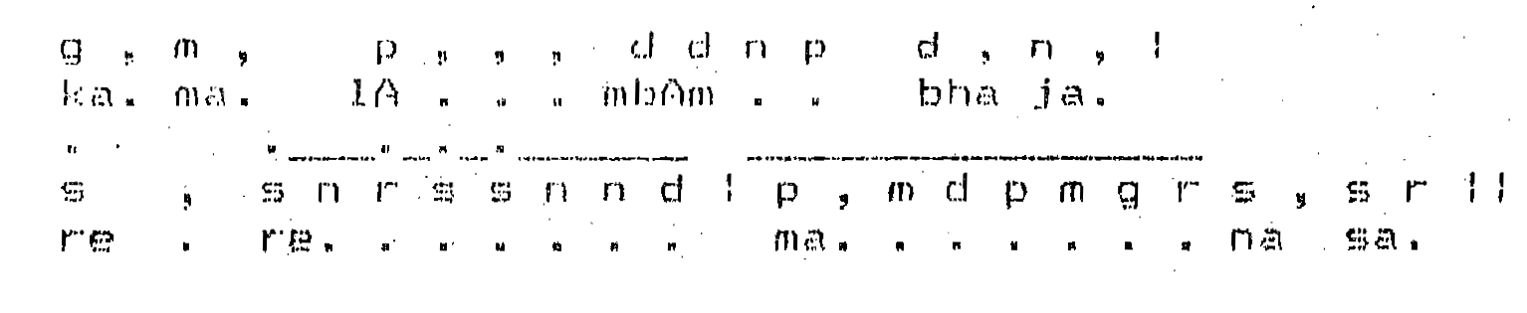

In the above example we see many specific phrases which have a uniform flow, along with the sahitya (text). The tempo of the kriti is also slow with more Gamaka’s and few Sangati’s.
Another important aspect characteristic of Dikishitar’s style is the presentation of glides or Jaru’s

Hiranmayim in the raga Lalita - tisra eka tala

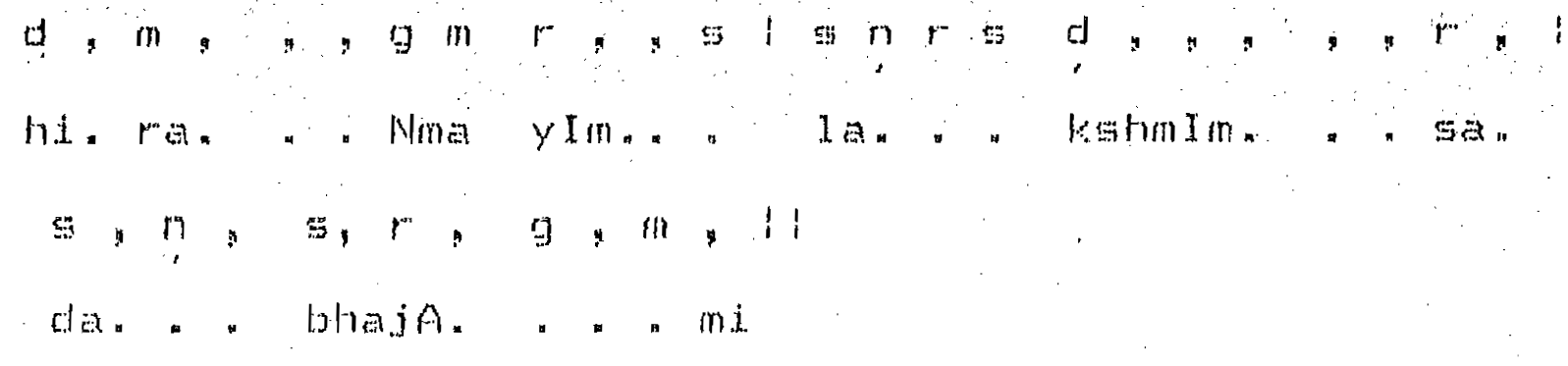

Shyama Shastri’s kriti style has more emphasis on unfolding the potentialities of the tala, while rendering the kriti. In Adi tala he followed the same compositional style of some of the composers like Pallavi Gopalayyar, Ghanam Krishnayyar and Kavi Matrbbutayya.

Palinchu kamakshi in Madhyamavati can be considered as a good example.The musical structure is made of uniform phrases in Samakala. There is usually a continuous flow of music without much pauses in between, there are more words in the Sahitya with a vowel extensions.

Anupallavi of the kriti Palichu Kamakshi

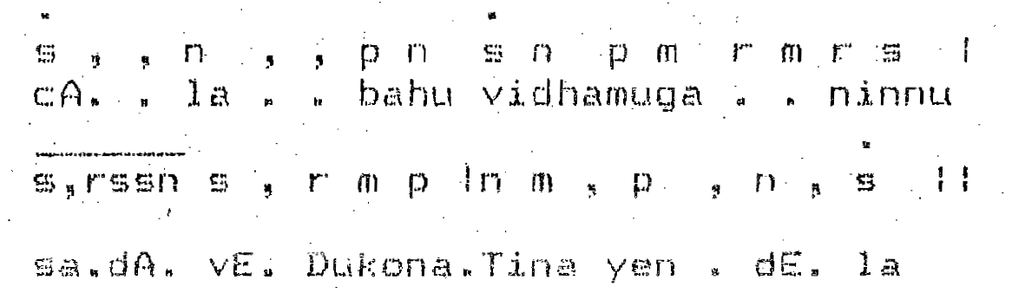

In present day music we find that the compositional styles of the trinity have been integrated. While it became a musical fashion long ago, to sing Dikshitar kriti’s like Tyagaraja kriti’s presently even kriti’s of Shyama Shastri are sung like a Tyagaraja kriti. Such integrations of the great styles of the trinity has resulted in the loss of the grand individuality of the composer and kriti’s of Dikshitar and Shyama Shastri become a mere nomenclature. It is Tyagaraja’s compositional style in his kriti forms that continues to be popular.

