5 Things You Didn't Know About Guangzhou(GZ)
City Weekend is your go-to place for GZ info, so we thought we'd treat you with a few interesting facts which you may not know about the Flower City. For new arrivals and hardened GZ veterans, here are some tasty bits of Guangzhou trivia.

1. Chairman Mao Once Lived in GZ
Although the big man is more commonly associated with Beijing (where you can still catch a glimpse of him in his mausoleum) and Hunan, his home province, Chairman Mao once lived in Guangzhou during the 1920s. Mao was in the city to lecture students at the Peasant Movement Institute (农讲所) in Yuexiu District. You can visit the institute and see his old bedroom, which along with the classrooms have been preserved. What he would think of today's commute on the crammed metro to the station beneath the institute, one can only wonder.
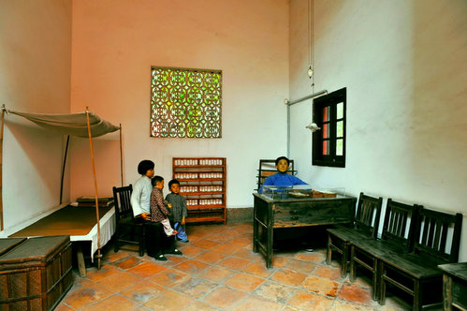
Chairman Mao's A/C-less room at the Peasant Movement Institute
2. There was a Massacre of Foreigners
Before you start to hurriedly packing and booking your ticket out of GZ, we should point out that the massacre took place in the ninth century. During the dying days of the Tang Dynasty (618-907), rich foreign merchants were made scapegoats for the countries troubles. In 878, an army led by Huang Chao, a rebel who had decided to fight the declining dynasty, entered Guangzhou and started killing the city's foreign merchants. It is believed that from 878 to 879 between 120,000 to 200,000 foreigners were slaughtered.

3. China's Oldest Mosque is in Guangzhou
The Huaisheng Mosque (怀圣寺) in Yuexiu District is the oldest mosque in China and one of the oldest in the world. The precise date of construction is debated. Ancient manuscripts say that the mosque was built by Muhammed's uncle Abi Waqqas, who came to China as part of the first Muslim mission in the 630s. What is known for sure is that the structure was there in the later period of the Tang Dynasty. Since then it has been rebuilt a number of times but thankfully the light tower, which is thought to been a type of beacon for boats on the river has remained intact.
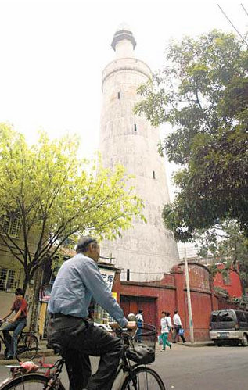
Huaisheng Mosque's Light Tower

4. GZ was the Capital of China
Although Beijing is now the capital city of modern China (post-1949), before the end of the civil war Guangzhou had been the capital of China not once, but three times. During the early half of the twentieth century, which was a tumultuous period in Chinese history when the country had multiple governments, was plagued with civil war and had to deal with foreign invasion, Guangzhou found itself the capital of the Chiang Kai-shek's Chinese Republic.
The first time the city became capital was from 1925 to 1927 when the national government of the Republic of China located to GZ before the march north to Beijing to defeat the rival Beiyang government. The second time was for a brief period during 1931 just a few months before the Japanese invasion of Manchuria. GZ again became the capital of the Republic of China for a third a final time for a couple of months during 1949 when Nationalist forces retreated south during the civil war with the communists.

5 Cantonese comes from Portuguese
Cantonese is not Chinese, in so much as the name Canton derives from the Portuguese word Cantão, which is thought be the Portuguese-tinged romanisation of 'Guangdong'. In 1514 the Portuguese were the first Europeans to arrive in Guangzhou and immediately created a trading post. However, in 1557 the Portuguese were kicked out of the city and were given Macau as a nearby trading base, which they kept until 1999.

About The Author...
Will is Web Editor for City Weekend Beijing. After a spell as Digital Publisher for City Weekend in Guangzhou he made the trek north to see what life is like in the 'big smoke'. His hobbies include football, endeavoring to master Mandarin and Cantonese, and wandering around Beijing in search of adventure.
Follow the link for the article: http://www.cityweekend.com.cn/guangzhou/blog/5-things-you-didnt-know-about-guangzhou/

